We are becoming a Learning Disability Friendly GP Practice / Primary Care Network (PCN)

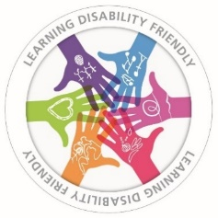

 | Being a Learning Disability Friendly GP Practice means that we:  - help you in a way that suits your needs  - complete good quality annual health checks
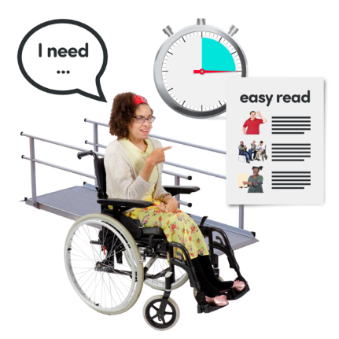 | Here are examples of reasonable adjustments you may need.  Only tick (choose) reasonable adjustments YOU need.
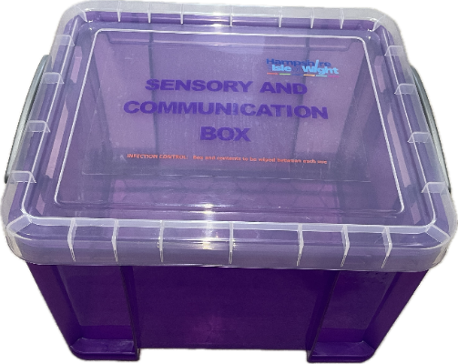 | We have a Sensory and Communication box available at the reception.  You can ask for it when you arrive.
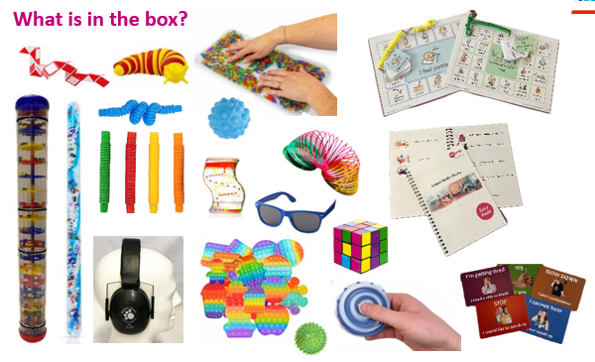 | These are some of the items on the box.  Please use them if that makes your experience with us better.
The reasonable adjustments you need to get the best care from us will be recorded on your medical record.

Reasonable adjustments examples.
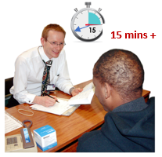  Longer appointment | or X |   Give me time to think | or X

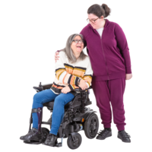  I need my carer with me | or X |   I use Makaton | or X

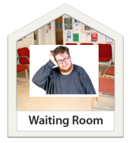  No waiting please, I get anxious | or X |   I need easy read | or X

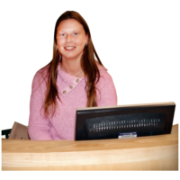  I need to talk to a person.  (No e-consult) | or X |   Talk to my carer about my health. | or X

I need appointment reminder by:

Phone Text Email Letter

If you don’t need an appointment reminder, tick here.

Other adjustments or information you want us to know about you:

Our Learning Disability Champions are:
HCA Nurse Kirsty Bott   | Kaylee Richardson
You can contact our Learning Disability Champions by:

- Phone: 01509 261843
- Email: bridge.street@nhs.net
- Speaking to Reception staff.

If you want to, you can give us feedback about your experience.
What is good about your doctor’s surgery?
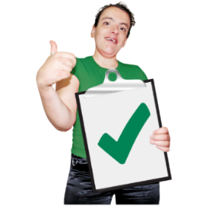
What is bad about your doctor’s surgery?


When you completed this form, you can choose how you return it to us. You can either:
- Bring to the surgery. Give this form to the reception staff.
- Post this form to this address:
20 Bridge Street, Loughborough, LE11 1NQ
- Email this form to: bridge.street@nhs.net

