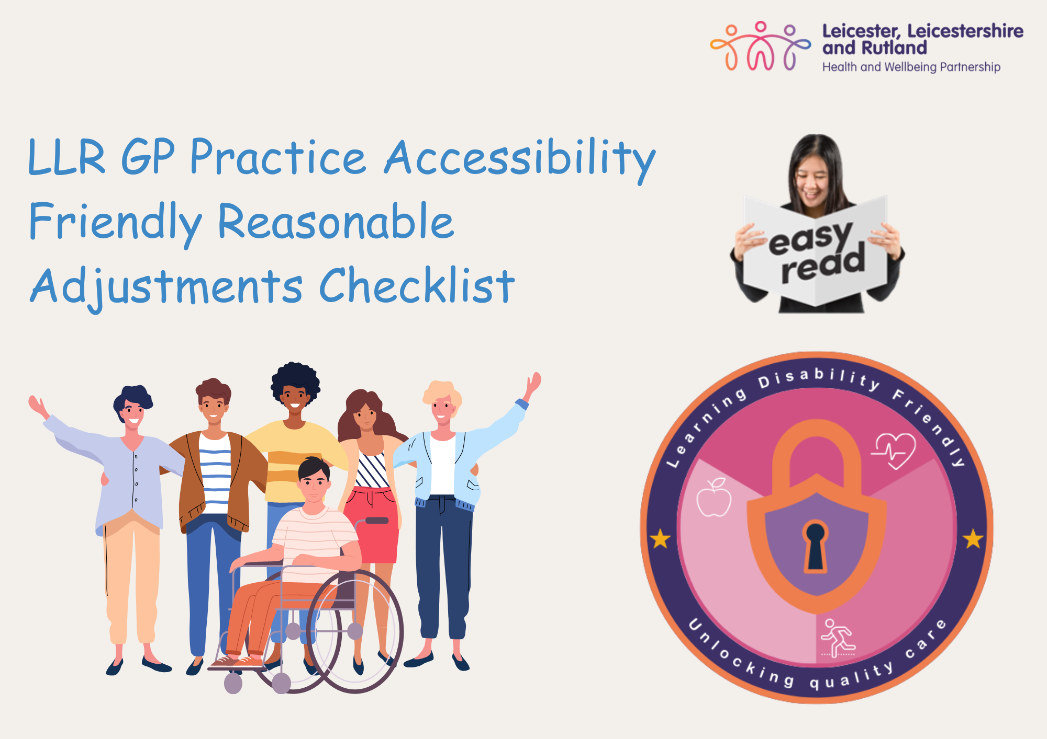

LLR GP Practice Accessibility Friendly Reasonable Adjustments Checklist
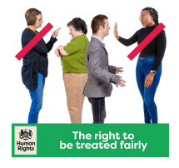 | A reasonable adjustment means making a fair change to services.  Everybody has a right to good healthcare. But a ‘good’ service does not mean treating everybody exactly the same.
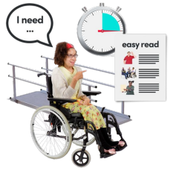 | People have different needs - so a reasonable adjustment means making the ‘fair change’ which is right for them.  In healthcare, there are lots of different reasonable adjustments (fair changes) that professionals can do, to make sure everyone gets the same good service.
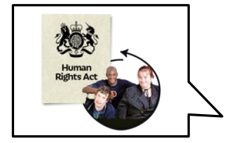 | It is important that people know they have a right to ask for a fair change which will help them.
 | We have made this checklist for GP practices to understand what reasonable adjustments people may need when coming to their practice.
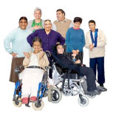 | This checklist is aimed to be completed with people who have lived experience.  People with lived experience and co-production are at the heart and centre of the learning disability collaborative.  Being involved can change people’s feelings of being left out into feelings of being valued, accepted and being able to make a difference.

Practice name: |  |  | Name of person from practice:
Name of person filling out the form: |  |  | Name of supporter:
Date that the checklist was completed:

Outside space
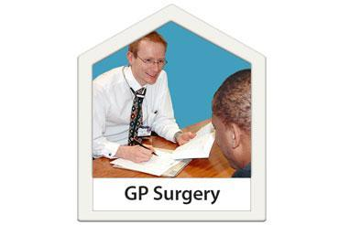 | Can you see the practice from the road or path?
 |   Yes |   No |  |  |   Not sure
Comments:
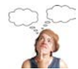
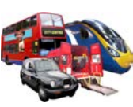 | Is there a bus stop or train stop nearby?
 | Yes | No |  |  | Not sure
 | Comments:
 | Can you find out how to get to the practice from their website?
 | Yes | No |  |  |   Not sure
 | Comments:
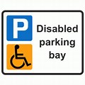 | Is there disabled parking with enough space for people to get out of the car safely?
 | Yes | No |  |  | Not sure
 | Comments:
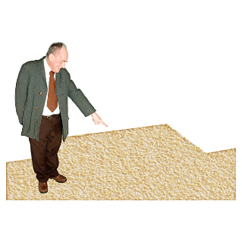 | Is there anything blocking the path to the surgery?
 | Yes | No |  |  | Not sure
 | Comments:
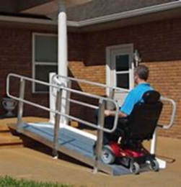 | Is there a slope to the practice if needed?  If there is a slope, does it have two handrails?
 | yes | No |  |  | Not sure
 | Comments:
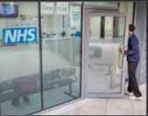 | Can the door be opened without touching or can it be opened by pushing it with one finger?
 | Yes | No |  |  | Not sure
 | Comments:
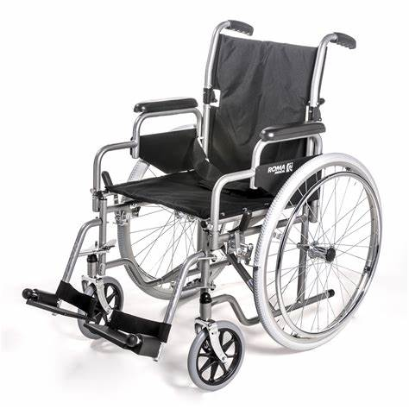 | Are there wheelchairs for people if they need them to use?
 | Yes | No |  |  | Not sure
 | Comments:
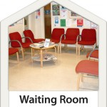
Reception area and waiting room
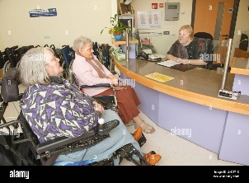 | Is the reception desk accessible to people in wheelchairs?
 | Yes | No |  |  | Not sure
 | Comments:
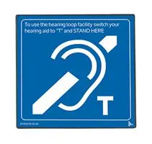 | Is there a hearing loop for people who need it (a hearing loop is a special type of sound system to help people who wear hearing aids)?
 | Yes | No |  |  | Not sure
 | Comments:
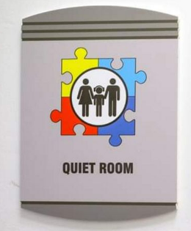 | There is a quiet room for people to wait if someone needs some space.
 | Yes | No |  |  | Not sure
 | Comments:
  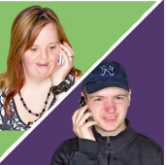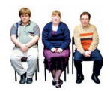 | Can the person leave if they want and be contacted by text or phone to let them know it is their turn for their appointment?
 | Yes | No |  |  | Not sure
 | Comments:
 | Is there space for someone to move about if they need to?
 | Yes | No |  |  | Not sure
 | Comments:
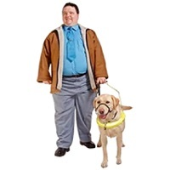 | Are companion and assistance animals allowed?
 | Yes | No |  |  | Not sure
 | Comments:

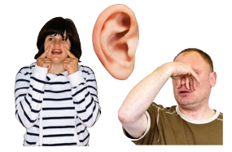
Sensory environment
 | Does the practice have plain coloured walls or are there lots of patterns on the walls or floor?
 | Yes | No |  |  |   Not sure
 | Comments:
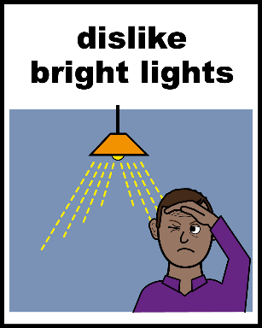 | Is the lighting too bright and/or harsh?
 | Yes | No |  |  | Not sure
 | Comments:
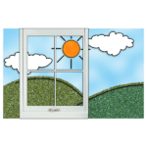 | Is the sunlight coming through the window too bright and/or harsh?
 | Yes | No |  |  | Not sure
 | Comments:
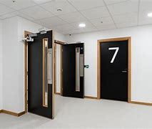 | Are the doors a different colour to the floor ?
 | Yes | No |  |  | Not sure
 | Comments:
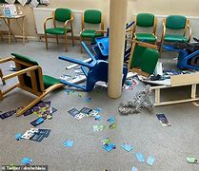 | Can you move easily around the practice or is there too much furniture or clutter?
 | Yes | No |  |  | Not sure
 | Comments:
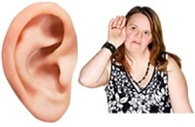 | Are there any noises that are distracting?
 | Yes | No |  |  | Not sure
 | Comments:
 | Can you open and close the windows to stop outside noise and change the temperature of the room?
 | Yes | No |  |  | Not sure
 | Comments:
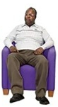  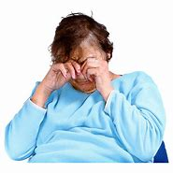 | Are the furniture fabric and covers comfortable?  Think about:  - Scratchy fabric  - Sweaty plastic covers
 | Yes | No |  |  | Not sure
 | Comments:
 | Are there any strong smells? For example:  - Cleaning products  - Animals  - Air fresheners  - Perfume  - Food
 | Yes | No |  |  | Not sure
 | Comments:
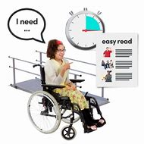
Communication
Complex and abstract ideas can be confusing. Consider whether the information can be made easier to understand by being simplified, or by explaining abstract ideas with examples of what they mean.

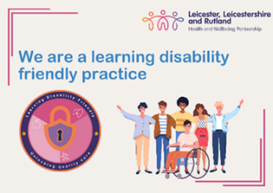 | Has the GP practice completed the LLR GP Friendly Practice Award? (This is a new assessment GP practices can do to understand how accessible they are for people with learning disabilities)?
 | Yes | No |  |  | Not sure
 | Comments:
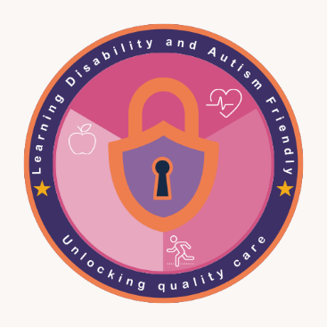 | Does the practice have learning disability champions (this is a new scheme starting in November)?
 | Yes | No |  |  | Not sure
 | Comments:
 | Does the practice have sensory equipment for people to use (they can contact their Primary Care Liaison Nurse to access one)?
 | Yes | No |  |  | Not sure
 | Comments:
 | Is there information available in accessible formats (Makaton, pictures, symbols)?
 | Yes | No |  |  | Not sure
 | Comments:
 | Is there pen and paper available for people who communicate better through writing or drawing?
 | Yes | No |  |  | Not sure
 | Comments:
 | Is the way to the rooms clearly signed and can the room be found easily?  Having a map or pictures showing how to get around a building may help people who cannot easily ask for directions.
 | Yes | No |  |  | Not sure
 | Comments:
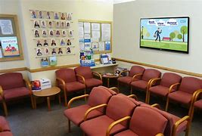 | Are there photographs of staff to help you recognise who is a staff member?  This could be on the room door so you know who is inside.
 | Yes | No |  |  | Not sure
 | Comments:
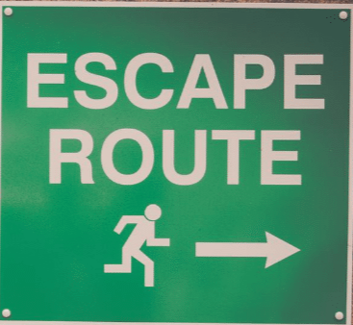 | Is there a space the person can exit or ‘escape’ to safely, such as a garden or another room?
 | Yes | No |  |  | Not sure
Comments

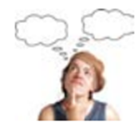

 | Using your checklist feedback, the GP Practice will now create an action plan.  This is something that you all might agree what/if any changes can be made
Signature of person completing the checklist: |  |  |  | Signature of GP Practice staff member:

A special thanks goes to people with lived experience who work with Insight training and consultation and for the contribution and hard work of the Valuing People Team, Adult Social Care, Leicester City Council who helped co-produce this checklist.
Additional thanks to:




